Learning Outcome 3 exam

**-- Create the database**

CREATE DATABASE IF NOT EXISTS library_db;

USE library_db;

**-- Create the books table**

CREATE TABLE IF NOT EXISTS books (

book_id INT PRIMARY KEY,

title VARCHAR(100),

author_id INT,

genre_id INT,

copies_available INT,

FOREIGN KEY (author_id) REFERENCES authors(author_id),

FOREIGN KEY (genre_id) REFERENCES genres(genre_id)

);

**-- Create the authors table**

CREATE TABLE IF NOT EXISTS authors (

author_id INT PRIMARY KEY,

author_name VARCHAR(50)

);

**-- Create the genres table**

CREATE TABLE IF NOT EXISTS genres (

genre_id INT PRIMARY KEY,

genre_name VARCHAR(50)

);

**-- Create the borrowers table**

CREATE TABLE IF NOT EXISTS borrowers (

borrower_id INT PRIMARY KEY,

borrower_name VARCHAR(50)

);

**-- Create the loans table**

CREATE TABLE IF NOT EXISTS loans (

loan_id INT PRIMARY KEY,

book_id INT,

borrower_id INT,

due_date DATE,

FOREIGN KEY (book_id) REFERENCES books(book_id),

FOREIGN KEY (borrower_id) REFERENCES borrowers(borrower_id)

);

**-- Insert sample data into the tables**

INSERT INTO authors VALUES (1, 'J.K. Rowling');

INSERT INTO authors VALUES (2, 'George Orwell');

INSERT INTO genres VALUES (1, 'Fantasy');

INSERT INTO genres VALUES (2, 'Dystopian');

INSERT INTO books VALUES (1, 'Harry Potter and the Sorcerer\'s Stone', 1, 1, 5);

INSERT INTO books VALUES (2, '1984', 2, 2, 3);

INSERT INTO borrowers VALUES (1, 'Alice Johnson');

INSERT INTO borrowers VALUES (2, 'Bob Smith');

INSERT INTO loans VALUES (1, 1, 1, '2024-03-15');

INSERT INTO loans VALUES (2, 2, 2, '2024-04-01');

DESCRIBE authors;DESCRIBE books;DESCRIBE loans;DESCRIBE borrowers;DESCRIBE genres;

**- 1. Show all books in the Fantasy genre.**

SELECT b.title FROM books b INNER JOIN genres g ON b.genre_id=g.genre_id WHERE g.genre_name=’Fantasy’;

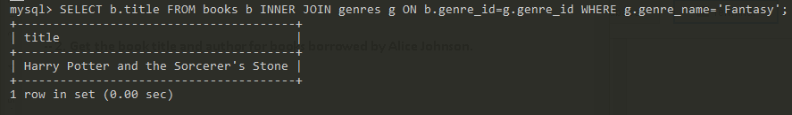

**-- 2. Get the book title and author for books borrowed by Alice Johnson.**

SELECT b.title,a.author_name FROM books b INNER JOIN authors a ON b.author_id=a.author_id INNER JOIN loans l ON l.book_id=b.book_id INNER JOIN borrowers bw ON bw.borrower_id=l.borrower_id WHERE bw.borrower_name=’Alice Johnson’;

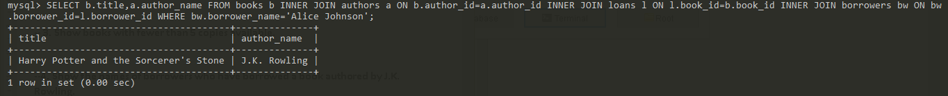

**-- 3. Show books with fewer than 5 copies available.**

SELECT title,copies_available FROM books WHERE copies_available<5;

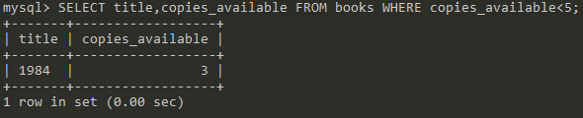

**--4. Show the names of borrowers who have borrowed a book authored by J.K. Rowling.**

SELECT bw.borrower_name,b.title,l.due_date FROM borrowers bw INNER JOIN loans l ON bw.borrower_id=l.borrower_id INNER JOIN books b ON b.book_id=l.book_id INNER JOIN author a ON a.author_id=b.author_id WHERE a.author_name=’J.K. Rowling’;

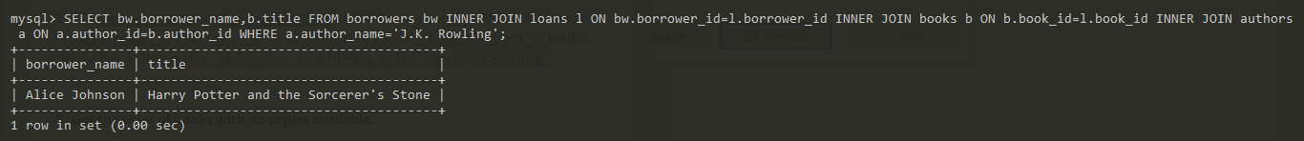

**--5. Get the titles of books with no copies available.**

SELECT title FROM books WHERE copies_available=0;



**--6. Show the borrowers who have not borrowed any books.**

SELECT bw.borrower_name FROM borrowers bw INNER JOIN loans l ON bw.borrower_id=l.borrower_id WHERE l.book_id=NULL;



**--7. Get the average number of copies available for books in each genre.**

SELECT g.genre_name, AVG(b.copies_available) AS avg_copies FROM genres g INNER JOIN books b ON b.genre_id=g.genre_id GROUP BY g.genre_name;

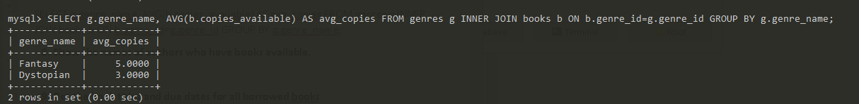

**--8. Show the names of authors who have books available.**

SELECT a.author_name FROM authors a INNER JOIN books b ON a.author_id=b.author_id WHERE b.copies_available>0;

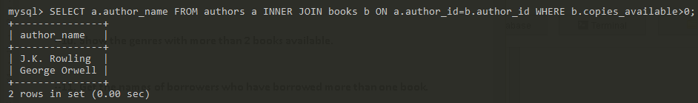

**--9. Get the book titles and due dates for all borrowed books**

SELECT b.title,l.due_date FROM books b INNER JOIN loans l ON b.book_id=l.book_id WHERE l.loan_id>0;

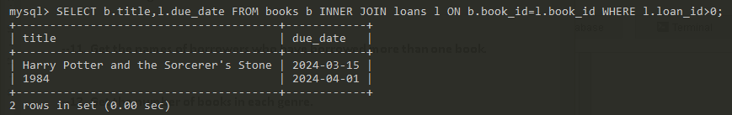

**--10. Show the genres with more than 2 books available.**

SELECT g.genre_name FROM genres g INNER JOIN books b ON g.genre_id=b.genre_id WHERE b.copies_available>2;

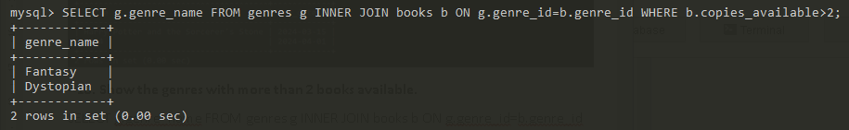

**--11. Get the names of borrowers who have borrowed more than one book.**

SELECT bw.borrower_name FROM borrowers bw INNER JOIN loans l ON bw.borrower_id=l.borrower_id GROUP BY l.borrower_id HAVING COUNT(l.borrower)>1;



**--12. Get the number of books in each genre.**

SELECT g.genre_name,COUNT(b.genre_id) AS num_books FROM genres g INNER JOIN books b ON g.genre_id=b.genre_id GROUP BY g.genre_id;

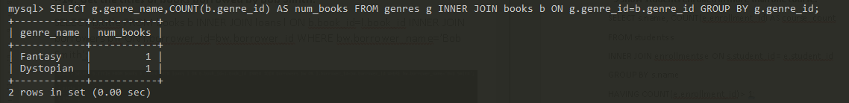

**--13. Show the names of borrowers who have overdue books.**

SELECT bw.borrower_name FROM borrowers bw INNER JOIN loans l ON bw.borrower_id=l.borrower_id WHERE l.due_date<curtime();



**--14. Get the titles of books borrowed by Bob Smith.**

SELECT b.title FROM books b INNER JOIN loans l ON b.book_id=l.book_id INNER JOIN borrowers bw ON l.borrower_id=bw.borrower_id WHERE bw.borrower_name=’Bob Smith’;



**--15. Show the authors who have more than one book in the library.**

SELECT a.author_name FROM authors a INNER JOIN books b ON a.author_id=b.author_id GROUP BY a.author_id HAVING COUNT(b.book_id)>1;



**--16. Get the total number of copies available for all books.**

SELECT SUM(copies_available) AS total_num_books FROM books;

